Ocean Lu  
CS 4080.02  
Professor Yang  
10/29/19

Assignment #5

Task 1: <https://colab.research.google.com/drive/1eHqLmLP3Ni0UaR-MKmJCFfAU6qsJCyY6>

Program source code: Python

Output runs:

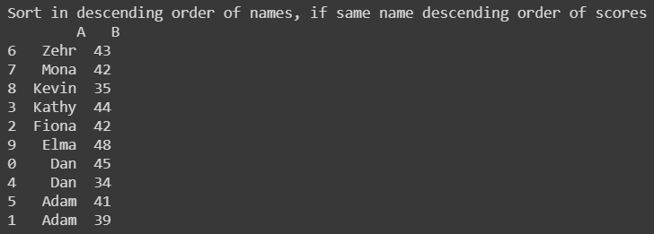

Task 2:

Program Source Code: Java

Output:

Tests:

Test to find the max value in a 2D array:

Test to find index (all), will be edited to return the first:

Testing given integer data:

Testing max value of String in 2D array:

Testing to find the index of the String:

